Dr. Alok Kumar
Firm’s equilibrium under Perfect Competition
PERFECT COMPETITION
Introduction:-
Perfect competition refers to a market situation in which there are a large number of buyers and sellers of homogeneous products. The price of the product is determined by industry with the forces of demand and supply.
For instance if we require a pen there should be several shops selling pens. Under conditions of perfect competition every seller should be selling the same quality of pens at a uniform prevailing price in the market. We may buy a pen from any shop at price rupees 10. If another shopkeeper charges rupees 12 for the same quality of pen, nobody will buy from him but if A shopkeeper charges rupees 9 all will buy pens from that particular shop. But both situations are unrealistic. There must be one price prevailing throughout the market.
Definition:- According to Mrs Joan Robinson- "Perfect competition prevails when the demand for the output of each producer is perfectly elastic."
Assumptions:- The main assumptions of perfect competition are as follows:-
1)Large number of buyers and sellers
It means no single buyer or seller can affect the price. If a firm enters into the market or exits the market there will be no effect on the supply. Similarly if a buyer enters into the market or exit from the market, demand will not be affected. Thus no individual buyer or seller can affect the price.
2)Homogeneous Products
The second assumption of perfect competition is that all sellers sell homogeneous products. In such a situation the buyers have no reason to prefer the product of one seller to another. This condition is present only when the commodity is a substance of definite chemical and physical composition.,i.e.,salt, tin, specified grade of wheat etc.
3)No discrimination
Under perfectly competitive market buyers and sellers must buy and sell freely among themselves. It implies that buyers and sellers must be willing to deal openly with one another to buy and sell at the market price. This may be true of one and all that may wish to do so without opening any special deals, discounts, or favours to selected individuals.
4)Perfect Knowledge
A competitive market is that kind of market in which the buyers and sellers are in close contact with each Other. It means that there is perfect knowledge of the market on the part of buyers and sellers. It implies that a large number of buyers and sellers in the market exactly know how much the price of the commodity is in different parts of the market.
5)Free entry or exit of the firms
In the long run under perfect competition form can enter into or exit from the industry. There is no hindrance on firms as far as entry into or exit from the market. In other words there are no legal or social restrictions of the firm. Large number of sellers can be possible only if there is free entry of firms.
Demand curve of a Product Facing a Perfectly Competitive Firm
Under perfect competition, a single price must prevail and therefore the demand curve or average revenue curve faced by an individual firm is perfectly elastic at the ruling price in the market. Perfectly elastic demand Curve signifies that the firm does not exercise any control over the price of the product but can sell any amount of the product as it likes at the ruling price.
Graphical Representation of Demand Curve under Perfect Competition
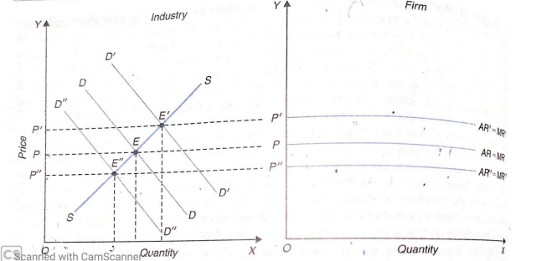
In the graph drawn above, the demand Curve DD and supply curve SS intersect at point E and determine price OP. Now the firm, having no influence over the price, will take the price OP as given and therefore the average-marginal revenue curve facing it will be as horizontal straight line at the level of OP. When demand increases and as a result price rises to OP', the firm will now confront the average-marginal revenue curve at the level of OP'. And if the demand decreases and price falls to OP'', the firm' s average-marginal curve will shift below to the level of OP".
Firm's Equilibrium Under Perfect Competition
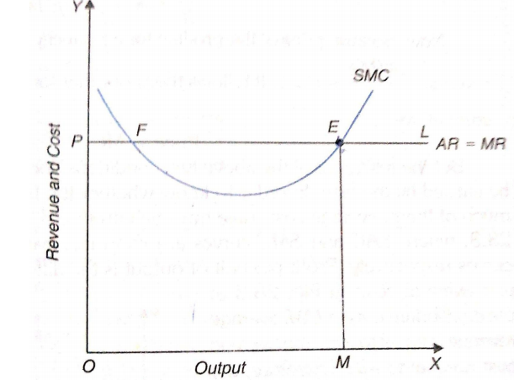
Marginal cost curve of the firm is U-shaped. Now in order to decide about the equilibrium output of the firm under perfect competition the firm will compare marginal cost with marginal revenue. It will be in equilibrium at the level of output at which marginal cost equals marginal revenue and marginal cost curve is cutting the marginal revenue curve from below. ​At this level it will be maximizing its profits. Since Marginal revenue is the same as price (or average revenue) the firm will equate marginal cost with price to attain equilibrium output. We consider the above mentioned graph for this,in which price OP is prevailing in the market. PL would then be the demand curve or the average and marginal revenue curve of the firm. It will be seen from the graph that marginal cost curve cuts average and marginal revenue curve at two different points F and E. F cannot be the position of equilibrium since at F second order condition of Firm's Equilibrium, namely, that the marginal cost curve must cut marginal revenue from below at the point of equilibrium is not satisfied. The firm will be increasing its profits by producing beyond F because marginal revenue is greater than marginal cost. The firm will be in equilibrium at point E or output OM since at E marginal cost equals marginal revenue as well as marginal cost curve is cutting marginal revenue curve from below.
Hence, the twin conditions of Firm's Equilibrium Under Perfect Competition are:-
A) MC=MR=Price
B) The MC curve must be rising at the point of equilibrium.

